Experiment - 10
Performance Optimization in Zoho Creator
SAI PRANAV B.V.
241401088 CSBS
AIM
To demonstrate performance optimization in Zoho Creator by using efficient record retrieval and workflow processing in the Patient Appointment & Scheduling Management application.
INTRODUCTION
Performance optimization in Zoho Creator involves designing workflows that retrieve and process only the records required for a particular operation. Efficient record retrieval reduces unnecessary processing and makes workflows more effective. In this experiment, criteria-based record fetching is used to identify the current appointment record using its unique ID instead of processing unrelated appointment records.
APPLICATION USED
Application: Patient Appointment & Scheduling Management
The application contains an Appointment_Booking_Form for recording patient appointment details. An existing form workflow sends an appointment confirmation using a Notification Template after successful form submission.
The workflow was optimized by adding a Deluge action that retrieves only the submitted appointment record before the notification action is executed.
PERFORMANCE OPTIMIZATION CONCEPT
The main optimization used in this experiment is criteria-based record fetching.
Instead of retrieving multiple appointment records and iterating through them to identify the required appointment, the current appointment is retrieved directly using its ID:
appointmentRecord = Appointment_Booking_Form[ID == input.ID];
Here, input.ID identifies the appointment record submitted by the current form transaction. This ensures that only the relevant appointment record is retrieved for further processing.
The workflow also checks whether the appointment record exists and whether an email address is available before continuing with the notification process.
PROCEDURE
1. Open the Patient Appointment & Scheduling Management application in Edit mode.
2. Navigate to Workflows → Form Workflows.
3. Open the existing send_appointment_confirmation workflow, which is triggered after a successful appointment form submission.
4. Add a Deluge Script action before the existing Notification action.
5. Use the following optimized Deluge script:
appointmentRecord = Appointment_Booking_Form[ID == input.ID];

if(appointmentRecord.ID == null)
{
info "Appointment record could not be found";
}
else if(appointmentRecord.Email_Address.isBlank())
{
info "Email address is missing for this appointment";
}
else
{
info "Appointment record retrieved successfully for " + appointmentRecord.Patient_Name;
}
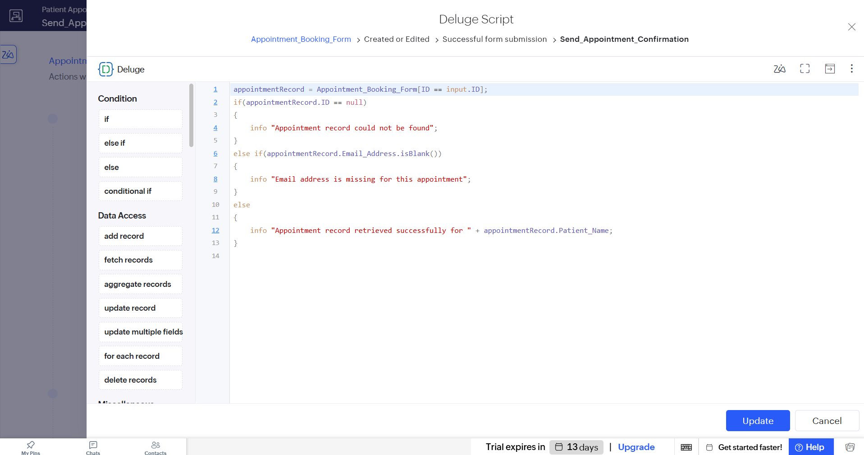
Screenshot 1 — Deluge script added to the send_appointment_confirmation workflow

6. Keep the existing Notification action after the Deluge action.
7. Use the existing appointment confirmation Notification Template and keep it configured as Execute without condition criteria.
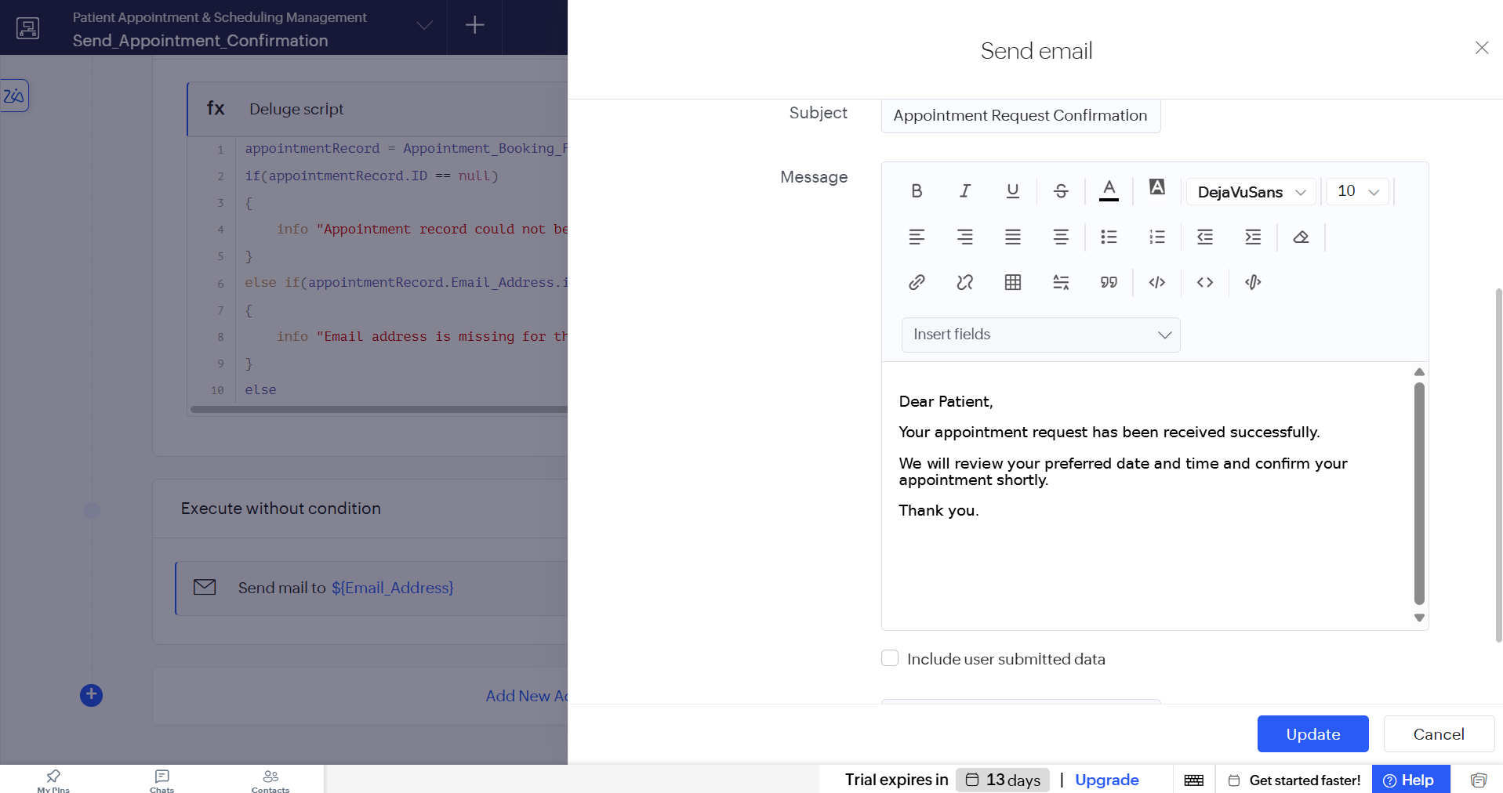
Screenshot 2 — Notification action configured after the Deluge action

8. Save the workflow and submit a test appointment through the application.
9. The workflow retrieves the submitted appointment using its ID and the notification template sends the appointment confirmation.

PERFORMANCE ANALYSIS
The workflow can be compared as follows:
Previous Approach | Optimized Approach
Retrieve multiple/unrelated appointment records | Retrieve only the required appointment record
Iterate through records to identify the current appointment | Identify the appointment directly using input.ID
Unnecessary record processing | Criteria-based record retrieval
Process records before identifying the required one | Identify the required record first and process it directly

The optimized approach avoids unnecessary record retrieval and iteration by using the appointment's unique ID. This reduces the amount of data that needs to be processed by the workflow.
OPTIMIZED WORKFLOW
The final optimized workflow is:
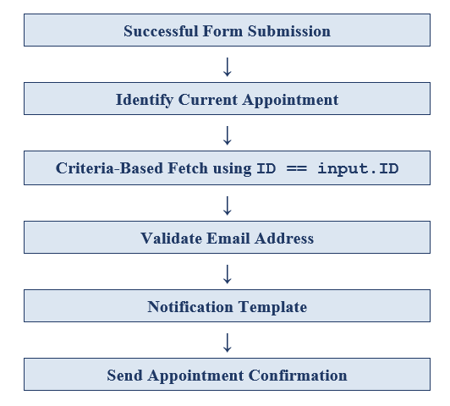
RESULT
Performance optimization was successfully implemented in the Patient Appointment & Scheduling Management application. The workflow retrieves only the required appointment record using criteria-based fetching with input.ID, avoiding unnecessary record retrieval and iteration. The existing Notification Template continues to send the appointment confirmation after the optimized processing.

